

Game Design Document Bullet Chess

Small Pawn, Big Dreams



Lucas Coveyduck, Ehsan Hussain, Tegran Tamrazayan, Ravneet Singh

Table of Contents

Executive Summary 2

Overview 2

Related Games 3

Player composition 4

World Aspects 4

General description 5

Game mechanics and Controls 6

Tasks/Schedule 10

# Executive Summary

You are a pawn that wants to reign supreme over the chess kingdom! Yet there are many other royal figures trying to impede your path to power. Thus, you must slay all your foes to become the top of the kingdom! Along the way you will gain more and more power with options to take on side activities. These side activities will cause thee to embark on many different puzzles to gain ultimate power! The game incentivizes speedrunning by giving the player the choice to skip the challenges and fight the bosses right away.

# Overview

The concept of “Bullet Chess” is a shoot em’ up, dungeon crawling, boss rusher where the player (you) is a pawn wanting to overthrow the kingdom. As you progress, you will acquire the power of the defeated bosses and will additionally be able to gain simple upgrades from completing challenges. Our game respects the player’s desire for challenge while not forcing every aspect of the challenges to be faced. Additionally, it will be easy to navigate while confirming that the player knows their controls early on to emphasize an easy to play, hard to master game style. The game will also be speedrunner friendly with ideally fast paced gameplay, though not restricting the game to speedrun only gameplay as it will also be rewarding for those who take their time.

# Related Games

**The Binding of Isaac** -[**Edmund McMillen**](https://bindingofisaac.fandom.com/wiki/Edmund_McMillen) **&** [**Florian Himsl**](https://bindingofisaac.fandom.com/wiki/Florian_Himsl)

[The Binding of Isaac:](https://bindingofisaacrebirth.fandom.com/wiki/The_Binding_of_Isaac:_Rebirth) Players will accompany [Isaac](https://bindingofisaacrebirth.fandom.com/wiki/Isaac) on a quest to [escape from the hand of his mother](https://bindingofisaacrebirth.fandom.com/wiki/Title_Sequence), facing off against mysterious [creatures](https://bindingofisaacrebirth.fandom.com/wiki/Monsters), discovering secrets, and fighting fearsome [bosses](https://bindingofisaacrebirth.fandom.com/wiki/Bosses). Along the way, Isaac can find bizarre [treasures](https://bindingofisaacrebirth.fandom.com/wiki/Items) that change his form and give him superhuman abilities. There are many paths you can take, and they all have their own endings. The game itself is very simple but the gameplay is made to drive anyone crazy. A very challenging game for beginners.

The Binding of Isaac made **$11,098,308.90** in gross revenue since its release. Out of this, the developer had an estimated net revenue of **$3,274,001.13**.

A lot of the many made was from their unique and fun addition to the game like dlcs

* [The Binding of Isaac: Afterbirth](https://bindingofisaacrebirth.fandom.com/wiki/The_Binding_of_Isaac:_Afterbirth),
* [The Binding of Isaac: Repentance](https://bindingofisaacrebirth.fandom.com/wiki/The_Binding_of_Isaac:_Repentance)

**Mega Man** - [**Keiji Inafune**](https://www.bing.com/ck/a?!&&p=9eaa12f02f5293f7JmltdHM9MTcyODUxODQwMCZpZ3VpZD0zZWNjNGZhZi02YWQ0LTYyZTMtMTIxZS01YWJiNmJlZjYzMGMmaW5zaWQ9NTIxMg&ptn=3&ver=2&hsh=3&fclid=3ecc4faf-6ad4-62e3-121e-5abb6bef630c&psq=megaman+7+creator&u=a1aHR0cHM6Ly9lbi53aWtpcGVkaWEub3JnL3dpa2kvS2VpamlfSW5hZnVuZQ&ntb=1)

The gameplay of “Mega Man 7”, is basically being able to use a sliding mechanic, being able to charge the “Mega Buster” , basically making it so you have more powerful shots. There was one extra feature in Mega Man 7, the concept of a Rush Search, you dig up useful items and when collected, you will be granted a Rush Super Adaptor, a combination of a powerful rocket arm attack and a jetpack for flying short distances.

Mega man is considered to be close to the first Boss rush game that was very well received by the players. Even though it kept its 2d fashion, the graphics revolutionized throughout the years. The latest game they released is Mega Man 11. For now, the Mega man franchise is worth up to 2.3 billion dollars. The merchandise sales like T-Shirts, cookie jars, bedding and many other sorts of items. Also, there is a show including Mega Man that brought in some cash.

**Cuphead** - **Chad Moldenhauer & Jared Moldenhauer**

Cuphead looks very cartoonish and its rage inducing mechanics, extremely difficult boss fights and very annoying run’n’gun. The game mechanics mix very well with every level. It’s a very simple game that gives you the choice to decide your abilities, the difficulty. This game alone has generated an estimate of $145 million in gross revenue and $43 million in net value, since its release. The DLC made the game even longer with the addition of new bosses and abilities.

# Player composition

This game is designed for people that are ready to experience pain and nothing else or people who prefer casual play. So yes, your little brother can play this game and even better, your grandma Margaret can play the game, but it’s at their own risk, because this game will put their sanity to the test (or not). However, the person should be of a certain maturity. Usually, we suggest that the player should be older than 10, because the game revolves around the concept of violence.

# World Aspects

The world of Bullet Chess is set in the Medieval era.

Background: The main character, Andrew, lives in the slums of the Andrwyn kingdom. This kingdom is ruled by the royals and supported by their people. Each day, he sees his people suffer under the hands of the tyrant Queen Andrella. He sees his people die of diseases and hunger every day, yet the Queen feigns ignorance to the people of her kingdom. One day as he was returning from work, he saw the Queen’s people entering his house. He witnesses his husband, Andreezy and his son Andres, being slaughtered by the corrupted Queen’s knights for disobeying the Queen’s command for more tax. Andrew’s husband and son are taken to the town square to be seen as an example of disobeying the Queen’s commands. Seeing this Andrew is taken over by his anger, drooling with vengeance as he heads towards the Castle. He decides to stop the cruel Queen’s dictatorship and take over the kingdom for the better of his people and the memories of his husband and son

Boss

Hub

Boss

Hub

Boss

Hub

Challenge

Challenge

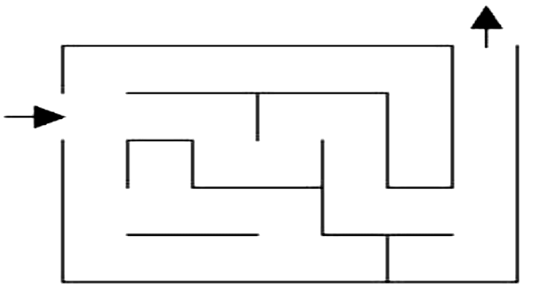

Challenge

Secret boss

Hub

Ending

Upgrade

Upgrade

Upgrade



Layout mock-up

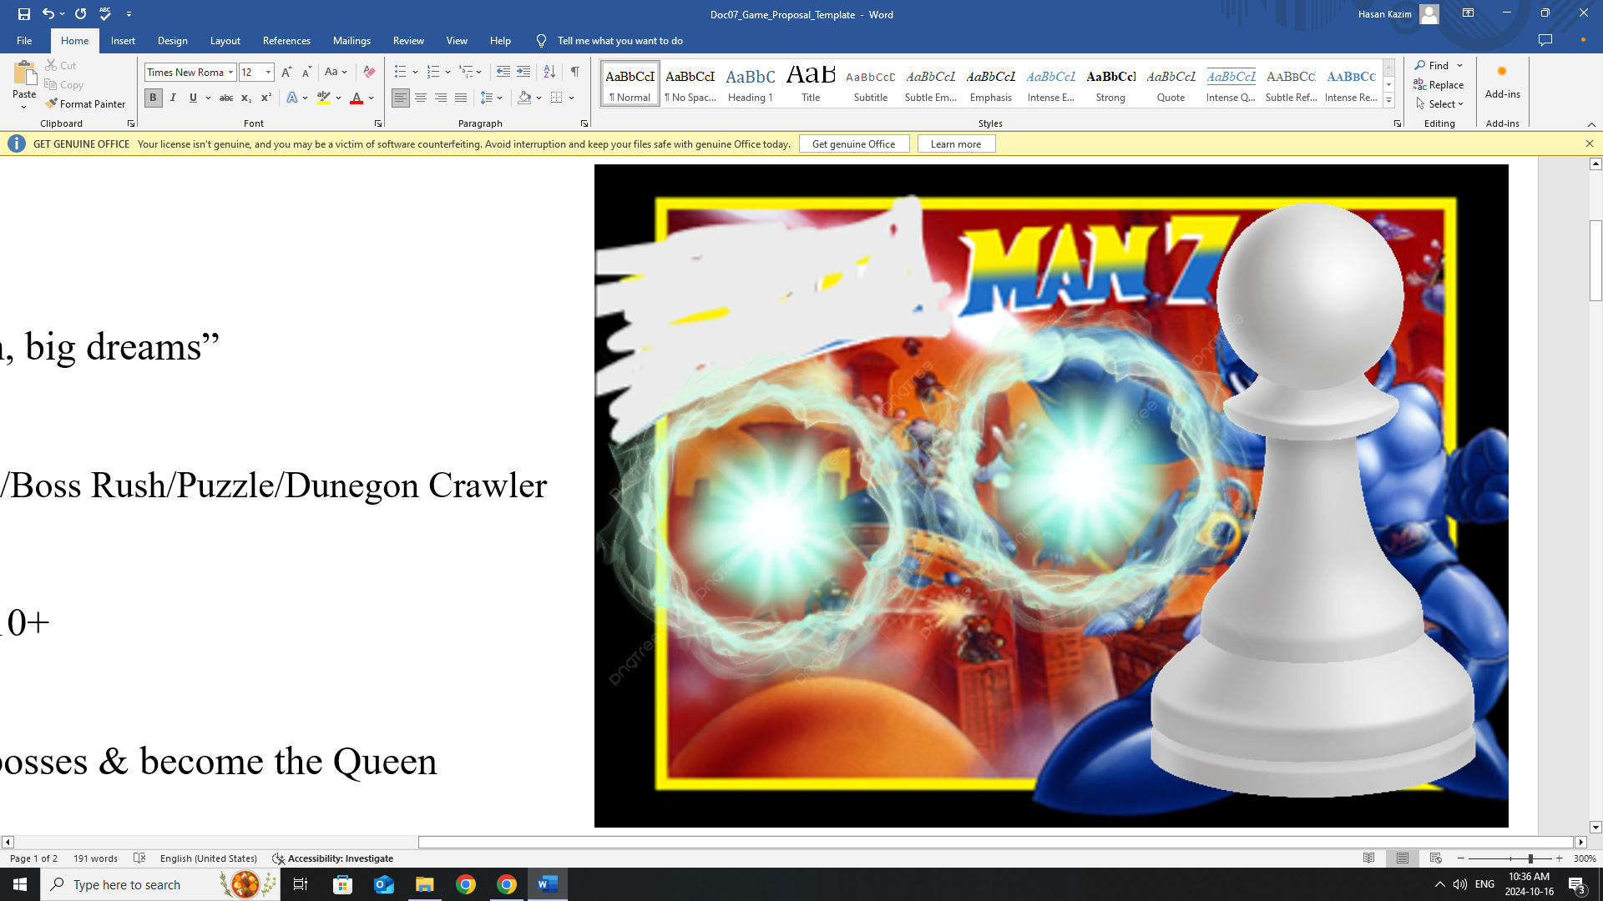

Play

Quit

Title screen Mock-up

# General description

The player starts the game at the central hub, where they then decide either to speedrun and go straight for the boss level or they complete a challenge to get a new weapon to help them defeat the boss. Each level a different boss will be presented to you and each boss will have unique attack patterns and unique ability. Once you defeat a boss, you will be given the option to either acquire a weaker version of the said boss's unique ability or march straight on ahead without the ability. After you defeat the boss, you will be moved to a mini hub, where you will be asked again to either complete a challenge or go straight for the next boss.

# Game mechanics and Controls

**Main character**

The Pawn

The main character will have the ability to shoot bullets with the arrow keys and move in any direction using the WASD keys. This will allow the player to move in one direction and shoot in the other direction simultaneously and independently. To interact with anything (such as doors, power-ups, checkpoints, etc.), the player would have to press the “E” key or the “Enter” key. The main character has three lives. If the pawn ever gets hit by an enemy, he loses a life and temporarily becomes intangible for a second. If the player loses all three lives, they lose the game and must restart from their last checkpoint. (If the player activates no checkpoint, they must restart from the beginning of the game.)

**Bosses**

The Knight

The knight is the first boss, and he has the ability to jump up in the air and slam down to create a shockwave around him. This will force the player to rely on their main source of damage (being the bullets) at long range rather than at short range. It'll take fifty bullets to kill the knight. Once the night is defeated, the player is rewarded with an optional power-up (with its instructions) and the right to the next level. The power-up gives the player the ability to shield.

The Bishop and Rook

The bishop runs around in a diagonal direction but slows down from time to time to rest. The rook runs around like the bishop, but in straight lines. The Rock and the bishop are paired together. It'll take fifty bullets to kill each boss. Once both bosses are defeated, the player is rewarded with an optional power-up to dash (including its instructions to the side) and the right of passage to the final boss.

The Queen and King

The queen has the move sets of all other bosses but is faster. The queen cycles between jumping up in the air to land with a shock wave and running around in a straight line. The king is an extremely slow-moving boss that will kill the player instantly (no matter how many lives they have). The king and queen share the same boss room. It'll take a hundred bullets to kill the queen and only twenty-five bullets to kill the king. Once both bosses are defeated, the player is rewarded with the right to access the final door which will show the credits and end the game.

The Secret Checker Pieces

If the player doesn't pick up a single power up and defeats all the bosses, the final door that would lead the player to the credits will be replaced with an extra save space and show two doors. The first door leads to the credits while the second door leads to the secret boss room. In the secret boss room, the player must fight a checker piece boss. The secret boss will move in a straight line in a diagonal direction (just like the bishop), but if they come close to the player, they will jump up in the air to land a shock wave attack (just like the knight). As the fight goes on, smaller checker pieces spawn to move in random directions (diagonally) to try and hurt the player character. The little minions die after two hits from your bullets, but the boss dies after a hundred hits from your bullets.

**Challenges**

Between each boss room, the player would have the choice to enter a challenge room. A challenge room will have the player traverse a series of obstacles that is usually associated with the upcoming bosses. This will act as a sort of tutorial to guide the player on what to expect from the bosses. Unlike the boss rooms, these rooms are completely optional with the player having the right to leave the room at any point and/or skip the room all together. If the player completes the challenge, they will be rewarded with a weapon upgrade that will change how the player shoots based on the respective upgrade.

The rooms to expect (in order):

1. Shoot-a-knight (Whack-a-mole)

There are 10 knights that fall from the sky and it's up to you to shoot them when they land before they jump back up and come back down in a random spot. If you succeed in killing all the knights, you get access to the homing shot. You must complete the challenge again, but this time you can use the homing shot.

1. Rooker and Bishop Road (Frogger/Crossy road)

Rocks are zooming left and right and it's up to you to make it to the other side. If you succeed in making it to the other side, you get access to the triple shot upgrade. To leave, you must complete the challenge again, but now it's the bishops that are zooming diagonally.

1. Queen's Gambit (Doom)

You are in a maze filled with two of every NPC you've seen so far (two knights, two rooks and two bishops). It is up to you to survive 30 seconds or kill every single one of them. If you succeed, you are given the bomb shot weapon upgrade. To leave, you must go through the challenge again, but this time there are no walls to protect you.

**Power-ups**

The shield

The shield is the first boss drop. To activate this ability, the player must press the “shift” key. Once active, the main character will block all incoming attacks for half a second. After use, the power-up enters a cooldown period for two seconds. This will allow the player to cancel any NPCs attack if they time it right.

The dash

The dash is the second boss drop. It allows the main character to move with great speed in the direction of whatever WASD key the player holds. If the player doesn't hold any key, then the default direction is up. To activate, the player must press the spacebar. Once used, it'll undergo a recharge time of two seconds. This will force the player to only rely on it during desperate times such as narrowly avoiding attacks.

The Homing Shot

The homing shot is the first upgrade you can have for your bullets. By pressing the “1” button on your keyboard, you can make your bullets automatically aim towards your enemies. The only downside is that these bullets do half as much damage as your regular bullets.

The Triple Shot

The triple shot is the first upgrade you can have for your bullets. By pressing the “2” button on your keyboard, you can shoot three bullets at a time instead of one. The only downside is that these bullets do half as much damage as your regular bullets.

The Bomb Shot

The bomb shot is the first upgrade you can have for your bullets. By pressing the “3” button on your keyboard, you can hold down an arrow key to power up your shot and let go to shoot. The shot should be twice as strong as your regular bullets. The downside is that you must hold onto the arrow button for three seconds, before shooting your bomb. If you only hold the key for one second, you shoot nothing. If you hold for two seconds, the bomb only does half as much damage as your regular bullets. If you hold for five seconds, the bomb will explode on you, causing you to take damage.

# Tasks/Schedule

|  |  |  |
| --- | --- | --- |
| **Tasks** | **Members** | **Schedule**  **(due dates)** |
| Title, win, and loss screen | Lucas | Oct 20 |
| Hubs, boss rooms and doors (transitions) | Lucas | Oct 27 |
| Main character | Ehsan | Oct 27 |
| Checkpoints | Lucas | Nov 3 |
| Challenge rooms | Ehsan | Nov 10 |
| NPCs and bosses | Tegran & Ravneet | Nov 17 |
| Power-ups and upgrades | Tegran & Ravneet | Nov 24 |